21.53: For an infinite plane sheet,  is constant and is given by 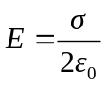 directed perpendicular to the surface.
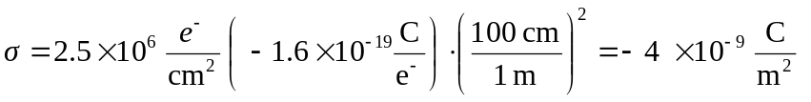
so 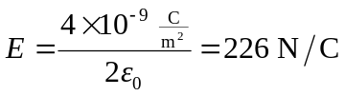 directed toward the surface.

